Eyes On The Road

START HACK 2017, St Gallen, Switzerland

Patroklos Anagnostou, Russell Buchanan, Johan Byther, Johnathan Lehner

# General Description

Eyes on the road is a hardware and software sensor suite designed to prevent drivers from falling asleep at the wheel. Using advanced sensor fusion and face tracking trained with a neural network, the system can not only can tell when a driver is becoming fatigued but also predict tiring situations. A Bosch XDK and Logitec webcam are used to monitor car swerving, temperature, driver nodding off and more.

# Purpose of the Project

The motivation behind the project lies on the fact that fatigue plays a role to a significant percentage of all the car crashes every year, with up to 4% of the officially reported crashes being related to sleep (source: [European Commission](https://ec.europa.eu/transport/road_safety/specialist/knowledge/fatique/fatigue_and_road_crashes/frequency_of_fatigue_related_crashes_en)). The percentage is higher on incidents in highways and is one of the most lethal dangers for professional drivers who are doing long repetitive distances.

With the upcoming technological revolution on autonomous driving, drivers are expected to let their alertness and attention decline further when being on long trips, taking the decision to do large distances even when they are clearly incapable of keeping their response times up to standards.

Eyes on the road focuses in detecting when the driver is too tired to continue driving and alerts the driver that he should stop before he becomes a danger to himself and others.

# Block Diagram

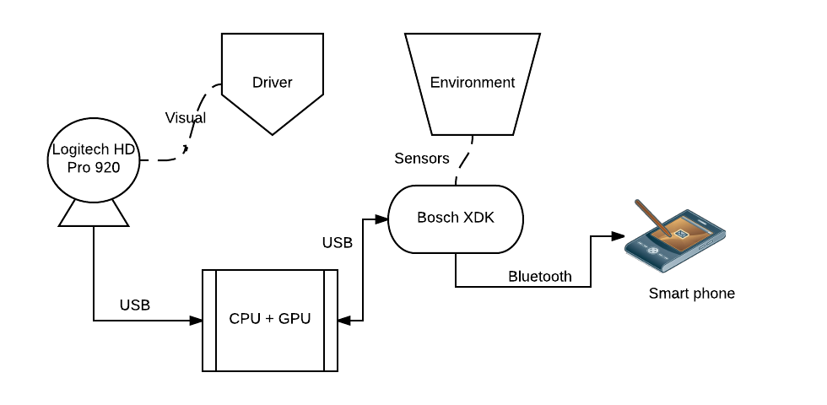

# System Description

The system relies on multiple sources of information to establish an estimation of the driver’s state with a sufficient level of confidence. Particularly:

* Video capturing from the Logitech camera is used for a 17-point face recognition algorithm, which are then utilized to understand drowsy patterns on the driver’s behavior
* The Gyroscope and Accelerometer sensors on Bosch’s XDK are used to detect potentially dangerous movements of the car, correlated to tired conditions of the driver.
* XDK’s Light sensor, together with the temperature and humidity sensor as well as the pressure sensor are used to determine if the environmental conditions favor the driver to fall asleep so that he must be alerted to be extra cautious.
* The algorithm that runs on the CPU+GPU which is the core of our system, combines the input vectors and generates responses.
* The XDK device alerts over BT the driver’s smartphone, where a native app of our system is running, so that the phone can play warning messages or control the songs and volume of the music the driver could be streaming to the connected car’s multimedia system.

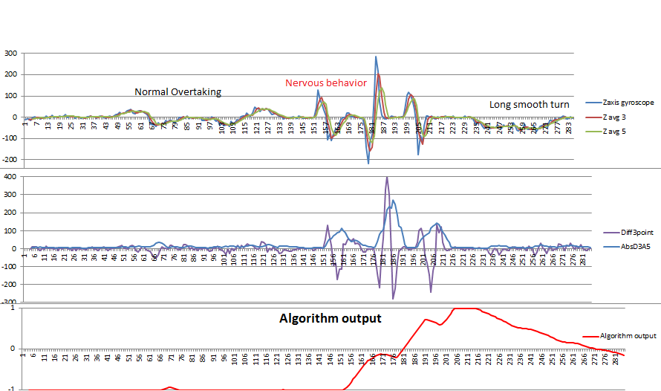

# Further improvements

* Optimization of the face tracking algorithm and the neural network by further training and more sophisticated use of its output
* More complex criteria applied on the XDK’s accelerometer and gyroscope values
* Machine learning algorithms on the individual drivers and their patterns
* Integration of more sensors, like MUSE for measuring brain activity of the driver
* Use of different hardware to run the various parts of the system and evaluation of its advantages and disadvantages
* More feedback to the driver through games that alert him without distracting him
* Use of the data to mark on maps the monotonous or more dangerous roads
* Studying the importance of the behavior of the other passengers and possible interractions